Project progress report

PROJECT STUDIO – NETWORKING_AND_SWITCHING

# Introduction

This document is written to give an outline of progress that the team has achieved, this is to ensure that our client is up to date on development, while also providing a summary of completed work.

# The progress

## Assumption

* The employee count is 250 and it is expected by the company to grow to 300 end users.
* We assume that all hardware is available for purchase by the business, and that it is within budget
* A VPN is not used for remote work and is instead accessed through a web interface/intranet. (Sharepoint / Teams)
* They do not have a proper file server, instead they use a NAS with 1 gigabit connection.
* There is no scalability, all routing is static and not dynamic
* There are no redundant devices or connections, if a device fails the network goes down with it.
* No business continuity plan for failed services
* There is no dedicated network security staff
* A router-on-a-stick configuration used for the entire company
* Congested network traffic
* Low bandwidth
* Backup solution is their old NAS server.
* The firewall equipment is outdated and does not support layer 3 switching. (Require a firewall)
* Outdated network and server hardware and not currently supported.
* Lack of network management (no remote management of devices. No SSH)
* No network monitoring system

**Stakeholders**

|  |  |
| --- | --- |
| System Stakeholders | Project Stakeholders |
| Employees (End-Users) Onsite/Remote | IT Team (Sys Admin, Support, Cyber Security Person) |
| IT Team (Sys Admin, Support, Cyber Security Person) | IT Manager |
| IT Manager | External Security Consultants |
| Executive Management | Executive Management |
| CEO | Finance Department |
| Human Resources | CEO |
| Board of Directors | Board of Directors |
|  | Vendors |

Equipment detail assumption

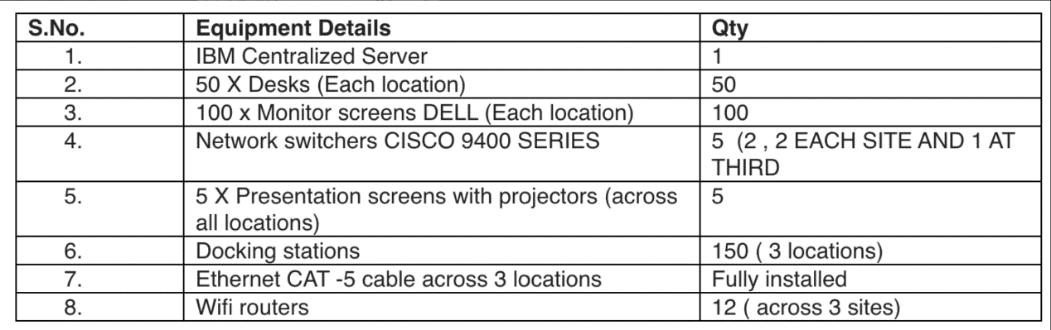

## Existing network

|  |
| --- |
|  |
|  |
|  |

### Network problem

* The topology relies heavily on the router identified as R1 as the central hub. If this router fails, a significant portion of the network will be disrupted since it connects to multiple switches.
* The **Multilayer Switches** are also points of potential failure. A failure in any of them would isolate all devices connected to it.
* The routers and switches are not connected by redundant paths. To guarantee that traffic can continue to travel through alternative routes in the event of a failed connection, a more fault-tolerant design would typically employ a mesh-like structure or redundant paths.
* In the event of a link or device failure, the primary router (R1) lacks a backup path to the access points or other routers (R2, R3), which could result in a network failure.
* Scalability appears to be restricted by the existing design. The current structure may not be able to effectively manage the additional burden if additional devices or switches are required, particularly at the access layer, where client PCs are connected.
* To segment the network effectively, it may be necessary to implement VLANs or Subnets, particularly as additional devices are incorporated.
* Typically, the multilayer switches are directly connected to the Access Points (AP). However, the addition of additional wireless devices may necessitate the implementation of centralised AP controllers to optimise the management of the APs.

## Backlog-sprint 1 goal

* Sprint 1 goal's user stories are finished to carry out the tasks that are consistent with the criteria that were given.
* All the task descriptions and subtasks were made to make sure that the work is fully known, planned, and done in a structured and effective way.
* The epics were also added to align with business objectives and facilitate the delivery of incremental value. Through that it also makes the work better in tracking the progress or manage the complexity

## Network topology

This design was made as a baseline design, that can be further expanded or altered to fit the needs of the client.

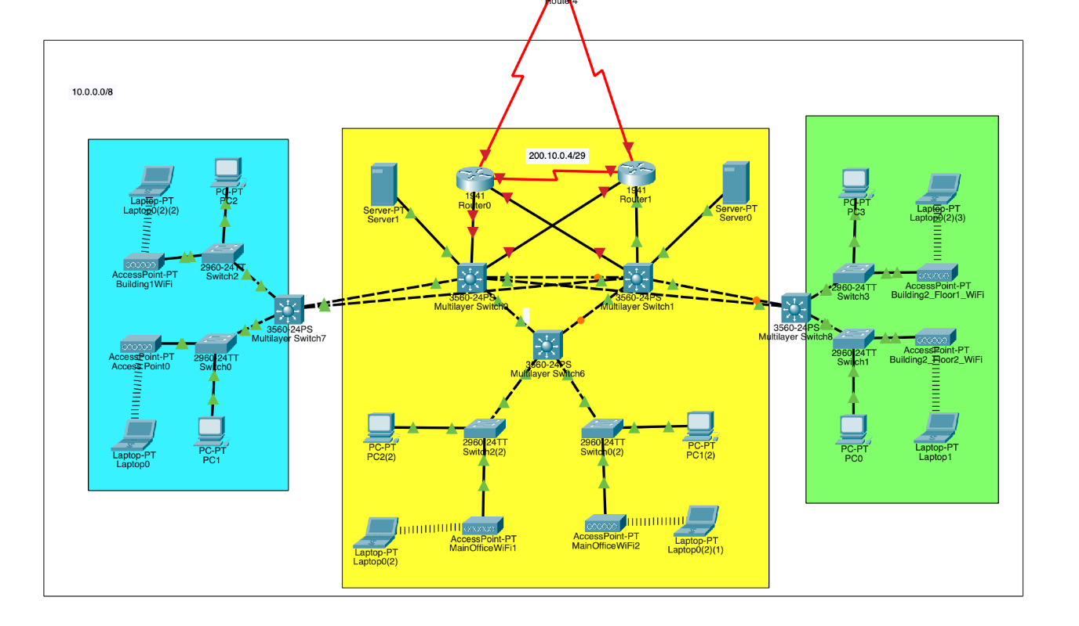This is our design for a high-cost high-end design that fulfills requirements. It currently does not have firewalls implemented; however, we plan on implementing hardware security (firewalls) in the next sprint.

We were unsuccessful in implementing the VPN this sprint, however we plan on implementing it next sprint.

In terms of documentation, we are working through hardware recommendations for the new hardware within a given budget (large budget, medium budget and low budget) to give a range of designs that could be utilised at different sites as needed; while still fitting within requirements. An IP Schema was created to supplement the new designs; further documentation will be created in future sprints to further supplement the network.

## Equipment Pricing

Here is an excerpt from our hardware research, sorted into budget sizes while also taking into consideration existing hardware.

The current network holds:

We are going to generate 3 solutions for the device selection which are low, medium and high cost. Taking into consideration the price of each unit/device; for each design, the current layer 3 switches and IBM Centralized Server will be reused as a cost saving method, as these devices are not necessary to be replaced. The medium and high-cost solution additional devices will be identified to

**Low-Cost Design:**

* **Reuse:** Old multilayer switch and servers.
* **New devices required:**
  + 1 server
  + 3 routers
  + 3 layer 2 switches

**Medium-Cost Design:**

* **Reuse:** Only multilayer switches.
* **New devices required:**
  + 4 routers
  + 2 servers
  + 7 layer 2 switches

**High-End Design:**

* **Reuse:** None, all new high-performance devices.
* **New devices required:**
  + 5 multilayer switches
  + 4 routers
  + 2 servers
  + 7 layer 2 switches

The items listed below will also be counted towards the total cost:

1: labour fees

2: subscription fees

3: maintenance fees

4: Consumables

See appendix A for the table containing the individual device choices and calculations .

Overall, the total price for each design, per location is:

**Low cost: $6326 AUD**

**Medium cost: $21330.61 AUD**

**High cost: $67995 AUD**

Each cost is per location following the recommendations, you may choose a different budget for each location, a location with very few workers will not need a very expensive

Below is a breakdown of why we chose each device, with justification

**Layer 3 switches**

Low-cost device solution: keep using the current switches

Cost: $0

Medium-cost device solution: keep using the current switches

Cost: $0

The current layer 3 switches that is in use by the current network is part of the Cisco 9400 series. These switches are among Cisco’s more recent higher end models, and in most situations do not need to be outright replaced, instead supplemented with lower cost switches leaving these switches to become the central distribution/core layer.

Detailed below is information about the series of switches:

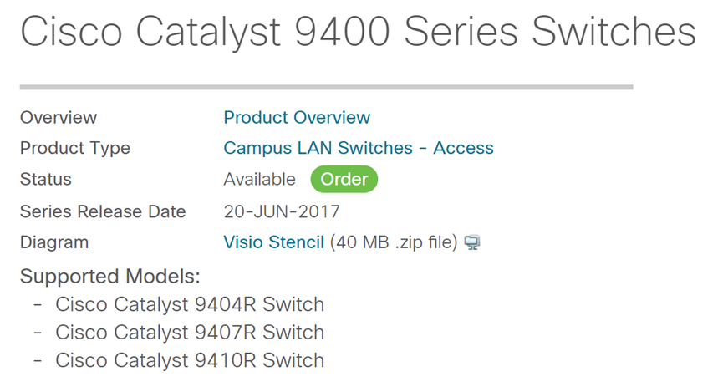

A single system can scale up to 384 access ports with choice of 10G, 5G and 2.5G multigigabit copper, 1G copper, Cisco UPOE®+, Cisco UPOE and PoE+ options, up to 384 ports of 10G and 1G Fiber, up to 164 ports 25G SFP28 options.

After all the 9400 series is qualified for the medium cost selection. The performance of the 9400 series device has better performance than most of the available layer 3 switches that fit into the budget for the medium cost, hence why the switches will be reused as the layer 3 switches for the medium cost design.

High cost: [Cisco Catalyst 9600 Series Switches](https://www.cisco.com/c/en/us/products/switches/catalyst-9600-series-switches/index.html)

Price: $24700

Justification:

The release date of the Cisco [Catalyst 9600 Series Switches](https://www.cisco.com/c/en/us/products/switches/catalyst-9600-series-switches/index.html) is April 29, 2019. This device offers high performance and scalability for enterprise networks. It is the best choose for our design is Cisco [Catalyst 9600 Series Switches](https://www.cisco.com/c/en/us/products/switches/catalyst-9600-series-switches/index.html) is a model that just been released few years back and it is one of the best switches from cisco.

wired switching capacity of up to 25.6 Tbps, with up to 6.4 Tbps of bandwidth per slot.

The reason why this model better than the others is, consider about the size of the network and future upgrading, this is the newest and best performance on the market right now.

**Layer 2 switches**

Low-cost solution: Cisco Catalyst 3650 Switch

Price: $230

Justification:

The Cisco Catalyst 3650 Switch provides integrated wireless controller capabilities, supporting up to 25 access points and 1000 clients, making it ideal for small to medium networks.

The reason why we choose this model is because this is the cheapest model in the market right now, it is the best solution for our low-cost solution.

Medium cost solution: Cisco CBS250

Price: $604.95

Justification:

This is Cisco's newly launched product in 2020, offering 24 Gigabit Ethernet ports. Its functionality fully meets the needs of existing networks. After comparing the price and performance, this is the best choice in its price range. Considering both price and performance, it is currently the best option on the market for medium-sized networks.

High-cost solution: Cisco Catalyst 9200L

Price: $2,172

Justification:

The Cisco Catalyst 9200L is ideal for high-cost switches due to its advanced Layer 2 routing, automation via Cisco DNA Center, and robust security features like TrustSec and MACsec. It ensures high availability with StackWise and redundant components, making it a reliable, scalable solution for enterprise networks.

**Server**

The current IBM server in use can be reused to save money, so the follow price range and recommendations have been made to fit these ranges

The range of the price based on the performance of the server.

|  |  |
| --- | --- |
| Server type | price |
| Entry-level | $1500-$3000 |
| Mid-range | $3000-$6000 |
| High-end | $6000-$12000 |

Low-cost solution: keep using the current server

Cost: $0

# Medium cost solution: ThinkSystem ST250 V2

Cost: $4,491.98 each

Justification:

The ThinkSystem ST250 V2 is the best medium-cost server for its Intel Xeon processors, storage, security. Its compact design and easy management make it an ideal, cost-effective solution for medium cost selection.

High-cost solution: ThinkSystem SR860 V3 Mission-Critical Server

Price: $16373 each

Justification:

The ThinkSystem SR860 V3 is an ideal high-cost server choice due to its performance, supporting up to four Intel Xeon processors and 16TB of DDR5 memory, making it perform well in heavy workloads. GPU could support up to 48 drives.

**Router**

Low-cost solution: cisco rv134w

Cost: $462 each

Justification:

The Cisco RV134W VPN Router is the best low-cost router for small businesses and home offices because it combines affordability with robust features like VDSL2 and Ethernet connectivity, advanced security through VPN and firewall capabilities, and Wireless-AC support. It's easy setup and deployment make it user-friendly, while the limited-lifetime warranty and free software updates provide peace of mind, ensuring reliable, secure, and cost-effective network performance ideal for small-scale deployments.

Medium: Cisco 900 Series Integrated Services Routers C921-4P

Cost: $826 each

Justification:

They provide robust internet access, secure broadband, and LTE WAN connectivity, making them ideal for small branch offices or managed-service environments. it performs well in a medium size network with decent price

High cost: Cisco 1000 Series Integrated Services Routers

Price: $1835.00 each

It has great feature as Cisco 1000 offer cisco IOC XE software, Catalyst SD-WAN and 4-6Gigabit Ethernet WAN ports offer the network a high performance enviroment.

**Labor**

According to research, the average qualified labourer charges 100 dollars/hour. To make sure the configuration and set up of the devices are correctly configured, we are going to use the standard market price for setting up of the network.

Layer 2 switch will take up to 1 hour to configure and layer 3 switches will take up to 2 hours.

Total price: $2100

**Cable**

We need 300 meters of cable for each site, hence 900 meters in total.

# Low cost: Dahua UTP CAT6 Cable 305M Blue Colour

Price: $505.5

Medium cost: Cat5e Ethernet Bulk Cable 350MHz

Price: $900

High cost: Cat6 Ethernet Bulk Cable 550MHz

Cost: $2370

**Miscellaneous Consumables**

* Subscription (Cisco U): $1600 per year
* Maintenance of the network: $1000 per year
* Maintenance of the devices: $1000 per year
* Connecters and adapters: $200

## Backlog - sprint 2 goal

* The team made changes to allow the system to handle twice as many users. This required upgrading crucial hardware and software to handle additional traffic without compromising security or performance.
* The VPN was implemented into the network design successfully. The technology balances load across numerous servers to minimise downtime and optimise performance even with more users.
* The team made changes to allow the system to handle twice as many users. This required upgrading crucial hardware and software to handle additional traffic without compromising security or performance.
* Our new physical topology diagram reflected the revised network structure. This graphic shows the new VPN components, fallback connectivity, and redundant hardware to ensure network transparency for future reference.
* The client received a detailed budget for VPN implementation, hardware improvements, and redundancy increases. This budget ensures that all expenses are adequately documented, giving the client a clear financial strategy.

## Backlog - final sprint goal

Recommendation of highspeed internet price

|  |  |  |  |
| --- | --- | --- | --- |
| Nbn Plan Brand (1000Mbps) | Speed | Upload Speed | Plan Price per month |
| TPG | 800 Mbps | 40 Mbps | 104.99$ |
| spintel | 650 Mbps | 42 Mbps | 105.95$ |
| swoop | 969 Mbps | 50 Mbps | 139.00$ |
| Southern phone | 860 Mpbs | 43 Mbps | 105$ |

# Appendix

## Appendix A: Cost breakdown table

It should be noted that this is per location

|  |  |  |  |  |  |  |  |
| --- | --- | --- | --- | --- | --- | --- | --- |
| Budget range | Layer 3 switch purchased | Layer 2 switch purchased | Server purchased | Routers  purchased | Cables (totalling 900m across all 3 sites) | Price of consumables | Total cost |
| Low | N/A | 3 X Cisco Catalyst 3650 Switch  ($690) | N/A | 3 X  [RV100 Series](https://www.cisco.com/c/en/us/products/routers/rv160-vpn-router/index.html) ($1386) | Dahua UTP CAT6 Cable 305M Blue Colour ($450) | $3800 | $6326 |
| Medium | N/A | 7 X Cisco CBS250 ($4234.65) | 2 X ThinkSystem ST250 V2 ($9091.96) | 4 X Cisco 900 Series Integrated Services Routers C921-4P ($3304) | Cat5e Ethernet Bulk Cable 350MHz ($900) | $3800 | $21330.61 |
| High | 5x [Cisco Catalyst 9600 Series Switches](https://www.cisco.com/c/en/us/products/switches/catalyst-9600-series-switches/index.html) 2 ($4700) | 7 x Cisco Catalyst 9200L ($15204) | 2x ThinkSystem SR860 V3 Mission-Critical Server  ($32746) | 5x Cisco 1000 Series Integrated Services Routers ($9175) | Cat6 Ethernet Bulk Cable 550MHz ($2370) | $3800 | $67995 |